MEDICAL CASEWORK


INFORMATION
BOOKLET
Index

Page 3 Introduction
An Important Note

Page 4 Contact Details

Page 5 Staff Details

Page 6 Informal Medical Boards – Common Problems

Page 7-8 Fmed 23 Guide

Page 9-10 Patient Advice Notice

Page 11-15 DMICP Referrals to Medical Casework and PMB Henlow
Page 16-17 Disposal on receiving referral from Medical Case Work
Page 18 Award of a L2 Marker
Employability Review Board Procedure
Release from the Service with a TMES

Page 19 Non-Effective Boards
Geographical Boards
Promotion / Further Service
OOA / Postings – How We Get Involved
Medical Discharges

Page 20 Disclosure of Information
Final Note
Introduction

This information booklet has been produced to assist Medical Centre Staff in raising understanding of the Department and what we can do to help you. It contains a brief insight in to what we do at Medical Casework (Med Cswrk) and why we contact you for information. It is not intended to be a comprehensive guide to Medical Boards.

You will also find a list of Department contact numbers and a brief (and by no means exhaustive) job description for each of us. This should make it easier for you when you need to call.

We welcome your phone calls. If we cannot answer your query, we can usually put you in touch with someone who can!

We are always happy to accept visitors. If you are interested, please call us to arrange a visit.

For those of you who have not visited the department, we are situated on Site 1, Promotion/ Medical Casework Dept Building 22 Room 1. We liaise closely with all departments situated within ACOS Manning on the following:

Fitness for Postings, Detachments, Promotion, Further Service
Compassionate/Preferential Treatment
Ministerial Correspondence
Review of Mode of Exit
Fitness for Families posted overseas
Pension Enquiries

Under no circumstance is medical information relayed to non-medical
personnel without the patient’s consent.

An Important Note

“It is the duty of the Medical Branch to ensure that the individual is awarded the appropriate Medical Employment Standard to protect his and the Service interest. What effect that has subsequently upon his career or promotion is a matter for the Executive and should not be entered into medical equation.”
The following information should assist you when contacting the Department:

- Address Medical Casework(RAF)
Room 1 Bldg 22
RAF High Wycombe
BUCKINGHAMSHIRE
HP14 4UE

- Tel Number Civ: 01494 49 Ext. XXXX
Mil: 95221 Ext. XXXX

- Fax Number Civ: 01494 49 5663
Mil: 95221 5663

- Internet E-Mail Air Mann-MedCswrk Gp Mlbx

- (see page 5 for individual intranet e-mail addresses)

STAFF DETAILS

Air-COSPers-Mann MedCswrk (Mcconnell, David Dr) (Ext. 3980)
Responsible for provision of advice to the PMA in all administrative procedures where doubt to a service person’s medical fitness exists

Air-COSPers-Mann MedCswrk1 (Pierre, Rudy WO) (Ext. 3979)
Supervision and management of all Dept. posts
Provision of advice regarding implementation of policy relating to Informal Medical Boards

Air-COSPers-Mann MedCswrk2 (Eyton-Hughes, Barbara Sgt) (Ext. 5030)
Processing documentation relating to changes to an individual’s MES
Provision of advice on the administration and policy relating to changes to MES's
Provide advice on DMICP issues relating to MES
Administration and advice relating to the award of a MES resulting in medical discharge, geographical posting and non-effective status
Processing Employment Review Boards

Air-COSPers-Mann MedCswrk3 (O’Connor, Samatha Sgt) (Ext 7728)
Processing documentation relating to changes to an individual’s MES.
Provision of advice on the administration and policy relating to changes to MES’s
Provide advice on DMICP issues relating to MES
Administration and advice relating to the award of a MES resulting in medical discharge, geographical posting and non-effective status
Processing Employment Review Boards

Air-COSPers-Mann MedCswrk4 (Evans, Carol-Ann E1) (Ext 3981)
Processing documentation relating to changes to an individual’s MES
Processing Discharge Employability Review Boards

Air-COSPers-Mann MedCswrk5 (Keen, Ben Mr) (Ext 4214)
Inputs all MES changes onto JPA
Receipt and despatch of all Department mail
Processing documentation relating to fitness for families posted overseas

Air-COSPers-Mann MedCswrk6 (Gohil, Uma Mrs) (Ext 7410)
Processing requests for access to Service medical records by ex-RAF personnel or their representative
Processing medical documentation relating to ‘Death in Service’
Processing medical documentation for all ex-RAF personnel

Air-COSPers-Mann MedCswrk Mlbx (MULTIUSER)

Please send all enquires to our Group Mailbox as regularly checked on a daily basis.

Intranet E-Mail - Air Mann-MedCswrk (followed by the post number)
INFORMAL MEDICAL BOARDS (IMB) – COMMON PROBLEMS

Over 1000 changes of MES are received in this department every month. They are all read to ensure that the administrative content is correct. Once inputted on DMICP/JPA, the trade desks have access to the MES and limitations. The following are some of the most common reasons why initial Informal Medical Boards IMB’s are returned to units for correction:

- Timeliness of IMB submissions. Your attention is drawn to AP1269A Leaflet 2-03 paragraphs 2f(1) & (2). It is important that this Office is informed of any MES awarded by IMB at the earliest opportunity.
- Awarding A4 L3 M6 E3 T – Limitation Code 116 – (Unfit Handling Live Arms) to Gunners/RAF Police/Eng Tech W.
Should be L4 – Limitation Code 224 (Fit for limited range of duties in trade – Unfit Handling Live Arms) (See AP1269A Lflt 1-02)
- When limitation Code 109 – Unfit for wearing Service Footwear is used, please specify the type of footwear
- If someone is upgraded for a condition and within the next 6 months, they are required to be downgraded again for the same condition, this period should be aggregated (See AP 1269A Lflt 2-03 Para 2)
- Psychiatric conditions should carry the limitations Unfit Handling Live Arms and Unfit Service Outside Base Areas as a minimum (see AP1269A Lflt 5-12) S7R attracts P7R and Unfit handling live arms (see JSP 346)
- Remember to include any appropriate permanent limitations in any subsequent temporary downgrading. Those limitations remain valid on their employability and should be included on the new TMES.
- For all Non-effective MES, please ensure that you include a contact address and telephone number in the F Med 23 narrative. (see AP 1269A Lflt 2-03 Annex E Para 5a(2)(e)).
- Limitation code 301 (Fit for detachments not exceeding 30 days in Z1 areas) is not compatible with P7R - should be P3R

- Please remember that when awarding a TMES for more than 6 months, a clinical update is required at 6 monthly intervals.

Forward all IMB’s via DMICP or for non DMICP units only to the group inbox

Air-COSPers-Mann MedCswrk Mlbx (MULTIUSER)

Enclosure No in  F Med 4 |  |  |  | F Med 23  (Feb 12)
 | MEDICAL BOARD RECORD
Service No. | Rank/Rating |  | Branch/Trade | Date of entry
Service Number | Rank/Title |  | Trade/Branch | Enlistment Date
Surname | Surname |  | Command | HQ AIR or Command of medical authority
Forename(s) | Forenames |  | Ship/Unit/Station | Unit/Station
Date of Birth | DOB |  | Type of enlistment  /commission | Period individual has signed on for
Gender | Sex |  | Normal date of termination of full time service | Date of discharge
Place of Board | Unit/Station board carried out |  | Date Non effective Commenced/ceased | Must be completed when assigned non-effective
Authority of Board | See AP1269A Leaflet 2-03 Annex A for list of authorities |  | Date this TMES episode started | (date of initial medical board or if initial board same as date of board)
Date of Board | Date Patient Presented |  | Date of review

Principal condition(s) affecting the medical employment standard leading to the Medical Board |  |  |  |  |  |  |  |  |  | Other condition(s) affecting the medical employment standard at the time of the Medical Board
Reason for downgrading |  |  |  |  |  |  |  |  |  | Ensure any relevant details are entered here including previous PMES awards
Date(s) of origin |  |  |  | Place(s) of origin |  |  |  |  |  | Date(s) of origin |  |  | Place(s) of origin
Date of injury |  |  |  | Location |  |  |  |  |  | Date of injury |  |  | Location

FINDINGS OF THE BOARD
P | U | L | H |  | H | E | E | M | S | Employment Standard, including any specific restrictions on employability and future plans
 |  |  |  |  |  |  |  |  |  | A |  | L |  |  | M |  | E
Limitations:

http://www.publications.raf.r.mil.uk/live/1269a/Section%201/Lflt%201-02.doc

Medical Deployability Standard |  |  |  |  |  |  | MFD/ MLD/ MND
JMES Status |  |  |  |  |  |  | Temp/ Perm/ N/A

1. Full Service Number |  | 2. Rank/Rating | 3. Surname and Initial
Service Number |  | Rank/Title | Surname Forenames
Date | Clinical Notes (To be signed by a Medical Officer)
DATE | The narrative is the responsibility of the medical officer downgrading the individual and must not be delegated to admin staff.  The following information is required:  Initial award – details of the presenting complaint, how and when it was presented and the treatment plan & prognosis.  Continuation and Upgrade – no need to repeat the details of the initial award. Give an update on what has happened since the initial award and what changes, if any, to the treatment plan & prognosis.  Initial award of L2 for each condition – on the initial award of L2 for each condition, there is no need to submit in FMB format, however, a concise summary of the complete history of the condition from initial downgrade to upgrade should be provided. If L2 for a previous condition(s), a short statement regarding the current status of the previous condition(s) should also be included. Details of previous condition(s) should also be included in the “Other conditions…” fields on the front page.
 | Name | Rank | Signature | Date
President | J BLOGGS | WG CDR |  | Date that the board is released by the MO for Med Cswrk approval
Member

Annex A to Leaflet 1-02 - Reassessment of Employment Standard – Patient Advice Notice (Dec 10)

Surname |  | Initials |  | Service No.
Surname |  | Forenames |  | Service Number
Rank |  | Trade/Branch |  | Unit
Rank/Title |  | Trade/Branch

 | Day |  |  |  | Month |  |  |  |  | Year
Effective from
 | Day |  |  |  | Month |  |  |  |  | Year
Due date of review
Medical Deployment Standard

New Medical Employment Standard (MES) | A |  |  | L |  | M |  | E |  |  | P/T or N/A
The individual’s employment standard is subject to the following limitations

Plain Language Version

I have attended a medical board and have been awarded the above MES.
*Informal Medical Board: I understand that the board proceedings, will be forwarded for approval to Manning Medical Casework who is responsible for advising the RAF Executive in their determination of my future employability. I do / do not* consent to Manning Medical Casework accessing my relevant medical record (including my electronic Medical Record) where necessary in order to give such approval and advice⁴. I realise that I must not commit myself or others to decisions based upon this MES until such times as the board proceedings are finally confirmed.

*Formal Medical Board: I understand that the board proceedings³, after approval of the RAF Medical Board if required, will be forwarded to Manning Medical Casework who is responsible for advising the RAF Executive in their determination of my future employability. I do/do not* consent to Manning Medical Casework accessing my relevant medical record (including my electronic Medical Record) where necessary in order to give such advice⁴. I realise that I must not commit myself or others to decisions based upon this MES until such times as the RAF Executive has confirmed my employability.

In both Informal and Formal Medical Boards: the board proceedings may be reviewed by Medical Officers working on behalf of COS Health/DGMS (RAF) in order that the health/medical fitness of the Royal Air Force can be monitored and the board proceedings audited. I do/do not* consent to COS Health/DGMS (RAF) accessing my relevant medical record (including my electronic Medical Record) where necessary in order to conduct health surveillance and audit.

*Non-Effective: I am / am not content that the SNCO RAF Medic, PHF RAF High Wycombe will need to access my medical record (including the electronic Medical Record) to ensure appropriate continuity of care is provided.

* Delete as appropriate
Signature of Individual Boarded |  | Date
Signature of the  President of the Medical Board |  | Date
President’s name  (block letters) |  | Unit

Distribution: Individual
Line Manager (Please see AP3392 Vol 5 Leaflet 138)

DMICP REFERRAL TO MANNING MEDICAL CASEWORK AND RAF MEDICAL BOARD
- This protocol details the procedure to be followed when referring patients to Manning Medical Casework and the RAF Medical Board RAF Henlow.
ACTIONS UNDERTAKEN BY THE UNIT MEDICAL BOARDS STAFF
- Administrative Duties.
  - Ensure that the individual’s medical record is active on DMICP
  - Select PD – Patient Documents
  - Select the relevant electronic F Med 7/F med 23 in and conduct the following administrative checks:
    - Personal details, dates correspond, unit details, authority of the board
    - PULHHEEMS Table matches DMICP template
    - Amendments to narrative
    - SNCO checks
    - Has been saved using the format as detailed below:
Field | Manning Medical Casework | RAF MB
Document Name | All documents are to be named iaw the Document Naming Convention using the following format:  <Date><Title><Protective Marking>  20080722- Title as detailed below-P-Medical  The title of the document will be from one of the following descriptions:
Document Name | IMB Initial  IMB Continuation  IMB Upgrade  IMB Geographical  IMB Non-Effective  IMB Exceptional Extension  IMB Request for Advice | FMB Referral  FMB Advice  FMB Unit Level Board
Assign Date | Date of Informal Medical Board or Request for Extension | Date of Referral, Advice letter or Unit Level Board
Description | F Med 7 or F Med 23 | F Med 7 or F Med 23
Read Code | TRIQQRE1 Refer To Medical Boards | TRIQQRE1 Refer To Medical Boards
Consultation References | To successfully link the document without causing duplication the ‘Link this attachment to a past consultation’ option is to be ticked (The ‘Link this attachment to the open consultation’ is not to be used because it creates a duplicate record).
Create A New Task To View This Attachment | To ensure that a robust audit trail is in place the examining MO is to inform the unit medical boards staff that the narrative has been completed by selecting the ‘Create A New Task To View This Attachment’ prompt followed by save. The ‘Add Task’ prompt will automatically appear. Select the ‘To’ switch and add the appropriate unit Medical Boards staff, additional information can be added to the text box if required. Once completed, select send.
- Forwarding the Electronic Referral. Once the completed documentation has been scrutinised by the Practice Manager or nominated deputy and the attachments have been added to the consultation, an electronic referral should be completed as follows:
a. Ensure that the individual’s medical record is active.

b. From the main menu select:

(1) MR – Medical Record.

(2) C – Consultations.

(3) From within the consultation select:
R – New Referral and the ‘Select Referral Type’ prompt will appear.
Select ‘Referral within the Primary Care System (PCS)’
Followed by OK
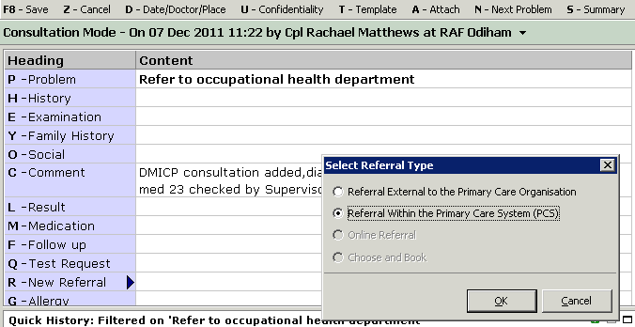
(5) The following administrative details are to be entered against the following fields within the ‘Referral within the Primary Care System (PCS)’ prompt:

(a) Select - Making a referral. By selecting this option, data will automatically be populated into certain fields there is no requirement to change these details.

(b) Term / Code: Enter the Read Code ‘8H7c – Refer to occupational health department’. (NB: The Read Code is case sensitive; ensure that above description is selected before proceeding).

(c) Team: Select ‘ROHT MB RAF Med Casework (RAF Med Casework)’ from the drop down options.

(d) Reason for Referral: Select ‘Management Advice’ from the drop down
options.

(e) Working Diagnosis: Annotate Initial,Continuation, Upgrade etc

(f) Link Attachment: Select the relevant F Med 7 / F Med 23 to be attached to the referral.

(g) Add to discussion list: For the referral to be forwarded to the designated team address this field must be ticked.
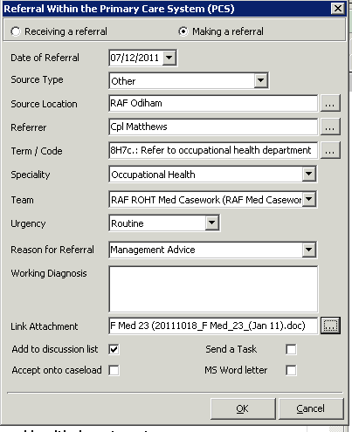
(h) Select U – Confidentiality, Change policy for consultation, select ‘Medical /Occupational Health @ RAF Odiham’ and ‘OK’
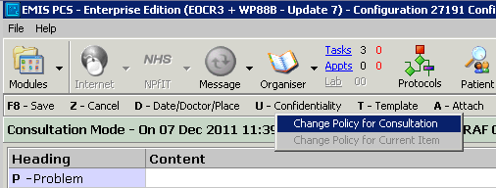

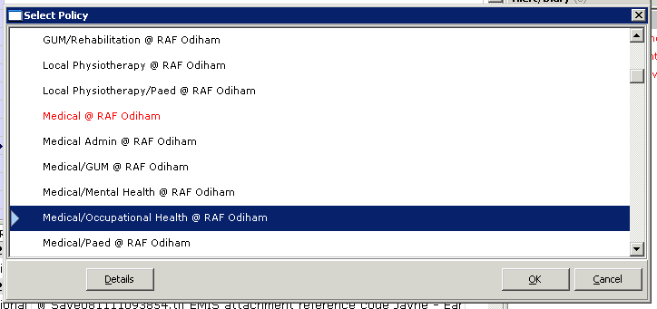

Select F8 – Save, to file the consultation.

(i) Select ‘Finish’ in the ‘Episode Management’ prompt.

- Press the Escape Key to exit without selecting any of the options from the ‘Service Work Absence’ prompt.
- Also ensure the Confidentiality policy has been changed for the document attached to the Referral.
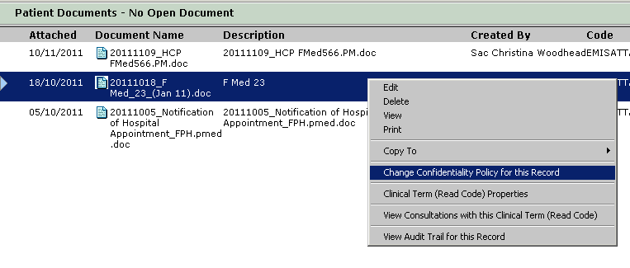
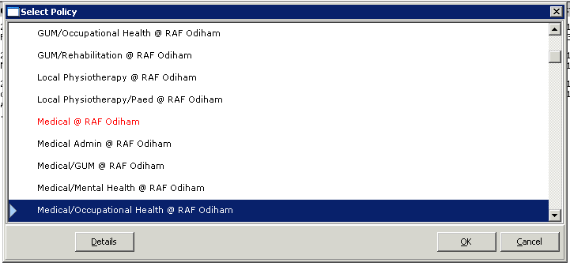

- Administration and Referral tracking
It is imperative that the unit Medical Boards staff have a robust system in place to ensure that the monitoring of referrals is tracked:
  - Within DMCIP ‘Referral activity’ under the sundial identifies any activity added to your referral i.e accepted onto external parties caseload, referral raise from external parties back to Unit to discharge from their care.
  - Once Manning Medical Casework has undertaken the appropriate action, the F Med 7 or F Med 23 will be discharged back to the referring unit via the DMICP Administration Lists. It is imperative that the DMICP Administration Lists are monitored frequently throughout the day
  - Task boxes are frequently checked throughout the day.
  - On the shared drive open the MES Spreadsheet and update the individuals details, in the comments box annotate ‘MCW’ or ‘Approved’ no other comments are required.
  - There is no requirement to forward the F Med 4 to Manning Medical Casework unless it has been specifically requested.

DISPOSAL ON RECEIVING REFERRAL FROM MEDICAL CASE WORK
Introduction
- This protocol details the procedure to be followed when an Initial TMES is returned from Medical Casework to the Medical Centre.
Procedure

- Book in via Admin List in DMICP


- Under (1) Referral discussion there will be a list of personal whose files are returned from MCW
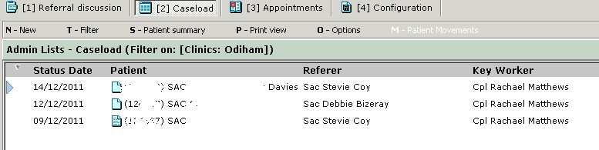

- Select the relevant individual this will highlight the individual in blue; by right clicking on the individual an option box will pop up. Select Referral details
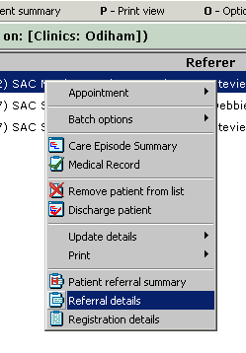
- A second option box appears containing the referral details back from Medical Casework and tells if the referral has been approved/not approved, select OK

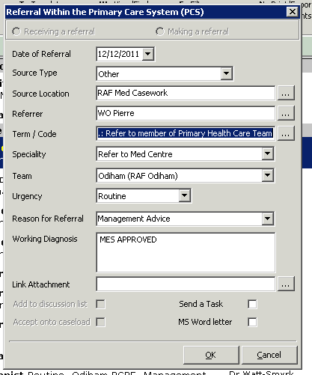

- You will find yourself in the individual’s medical records , select G- Documents

- From within the individuals documents, find the correct document that was sent to Medical Casework i.e F Med 23/7

- Open the document in edit mode and scroll to the bottom whereby you will find Medical Casework’s decision on the board
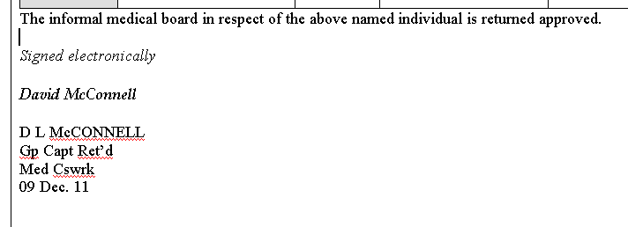

- Complete the following:
  - APPROVED
    - Photocopy the RAF Form 657 and F Med 566, the original copy is sent to the patient for his records and a copy sent to the patients line manager
    - Enter consultation on DMICP – MCWAPPROVED
    - Update JMES spreadsheet as found on the RMC shared drive

  - NOT APPROVED
    - Task referring MO to read F Med 23/7 and to see Medical Casework comments as to why the board was NOT approved.
    - Complete any admin action as necessary
    - Enter consultation on DMICP – MCWNONAPPROVAL
    - Update JMES spreadsheet as found on the RMC shared drive

AWARD OF A L2 CATEGORY

Your attention is drawn to AP 1269A Leaflet 1-02 Para 10.

Although an individual with a L2 category may currently have no disability or limitation to duty, it does not mean that they will remain fully fit in the future nor does it imply that they will be extended beyond their current terms of service.

EMPLOYABILITY REVIEW BOARD (ERB) PROCEDURE

All Officers and Airmen who have a Permanent Medical Board and are awarded an MES below P2 A4 L2 M1 E1 P (except in cases of Splenectomy) will be subject to an Employability Review Board (ERB). On receipt of the Medical Board documentation into this Department from RAFMB, the ERB is raised and passed to the executive for the final decision. The possible outcomes of the ERB are:
- Retain in Service until current exit date or for a period of time decided by the executive then review.
- Retain in Service but remuster to alternative suitable trade/branch.
- Discharge from Service.

At the time of the Medical Board, the Service person will be given the opportunity to make their own statement which will be forwarded to ACOS Manning and taken into account at the time of the review board process. It is not mandatory to make a statement and if one is not received within 10 days, the review process will proceed without it. They will also be given an information sheet advising them of the full process.

We understand that the Service person will, in most cases, be keen to find out the results of the board. These questions should be directed through their parent unit HR staff and not through Medical Casework. This Department is not routinely advised of the outcome of the ERB.

It is worth remembering that Medical Casework can make recommendations when requested but do not make decisions on a serviceperson’s career.

RELEASE FROM THE SERVICE WITH A TMES

It is permissible for personnel to leave the Service whilst holding a temporary MES providing the medical problem is neither serious nor likely to lead to later significant disability. Advice may be sought from the President RAF MB in writing. In cases where the problem is significant, the individual is to be referred for specialist advice using the fast track referral system, prior to a request for the award of a permanent MES by the RAF MB. Please refer to JSP 346 Chapter 1 paragraph 1.15 and AP1269A Leaflet 2-01 paragraph 12.

NON-EFFECTIVE BOARDS

Please ensure that there is enough clinical information included in the summary and that it is raised and sent to us promptly. Once the board is received, we aim to reach a decision on approval within 1-3 working days. If approved, the documentation will be returned to you for your action. We notify Personnel Holding Flight and the Career Manager that the patient has been awarded a Non-Effective MES and ask them to decide on whose Non-Effective strength they should be held. The Chief Clerk at your unit will be advised once a decision has been made.

GEOGRAPHICAL BOARDS

Again, please ensure that these are raised and sent to us promptly. The board is raised in the best interests of the patient and therefore the sooner the patient is posted, the sooner they can be on the road to recovery. Once approved, we are required to advise the Trade Desk of the requirement for the geographical restriction. It is a good thing to remember that once they are recovered and upgraded, the individual is vulnerable for posting again. A Geographical limitation can only be in force for a maximum of 12 months (two periods of six months). If after one year the requirement for a geographical posting still exists, the individual is to be brought before the RAFMB which may then recommend discharge on medical grounds.

PROMOTION / FURTHER SERVICE

Medical Casework are asked to make recommendations for personnel who have been selected for promotion or further service where a medical condition exists and there is doubt about their future employability. A member of Medical Casework staff will contact the relevant medical centre staff via email for up to date medical information. On receipt, it is passed to the President of Med Cswrk for him to make his comment. The Service person will be informed of the final decision via his Chief Clerk.

OOA/POSTINGS – HOW WE GET INVOLVED

Occasionally we will be asked to make comment on someone’s fitness for OOA or posting. This is based solely on their medical condition and the location the career managers have indicated they are likely to serve. Once a recommendation has been made this will be passed onto the career managers who will inform the individual concerned.

MEDICAL DISCHARGES

RAF MB Henlow advise Medical Casework of all Unfit Further Service boards via DMICP. The patient will be placed on indefinite sick leave until they are advised of a date of discharge (via the Chief Clerk). When the documentation arrives from RAF MB, along with the F Med 4, boarding paperwork is raised and passed to the executive. Once completed, the F Med 4 will be returned to the parent unit for disposal in the normal manner.

DISCLOSURE OF INFORMATION

Under the DPA 98, Service personnel are entitled to receive copies of their F Med 4. Before they leave the service, they can either request a copy from their Medical Centre or, once they are discharged, write to Medical Casework 6. Alternatively, they can request that a copy is sent to their new GP.

FINAL NOTE

We hope that this information is helpful and relevant. Hopefully, you will have realised why things are often urgent when we request them. It may be worth considering that when we do contact your staff for information, it is in response to a question from the Manning Executive. This in turn means that there are career implications being discussed about the individual concerned. No one likes to be kept waiting any more than they need to when waiting for a decision on their career to be made.

Medical Casework would appreciate feedback on this document, please call WO Pierre (95221 3979) with your suggestions and ideas for items that can be included. We look forward to hearing from you.

Thank You.

Date that the narrative is actually written.
Date that the board is released by the MO for Med Cswrk approval. ? Year, month, day – Title – Protect - Medical
Insert MFD, MLD or MND
Insert a “P” for Permanent “T” for Temporary or N/A if there are no functional restrictions to MES.
³ Forms required in accordance with AP1269A, Leaflet 2-01, Annex B. ⁴ If consent is denied, advice and/or approval will be given based on routine personal information available to Manning, but without the benefit of the medical record.

